Wesham Town Council Monthly Meeting to be held on Thursday, 14th September 2023
at 7.30pm in the Committee Room, Wesham Community Centre.

AGENDA

APOLOGIES:

CODE OF CONDUCT AND STANDING ORDERS
Members are reminded of the standard of conduct they must adhere to during Town Council meetings.

DECLARATION OF INTERESTS:
Members are reminded that any direct or indirect pecuniary or other interests should be declared as required by the Council’s Code of Conduct for Members.

23/077 APPROVAL OF THE MINUTES OF THE COUNCIL MEETING HELD 18th July 2023

23/078 MATTERS ARISING – any item not covered by agenda or action list

- Co-option of Wesham Councillors – interviews 11th Sept 2023

23/079 POLICING ISSUES - none noted to review since 18th July 2023
- Crime Reports – police.org.uk website > area > PR4 3DR (WCC postcode)
- Policing Issues – to discuss any items raised by Councillors

In The Know info sent to WTC members re Anti Social Behaviour 23/08/2023

23/080 PLANNING -
- Planning Applications -

23/0292 – Solar Panels & Plant Room, Medlar Lane, Wesham

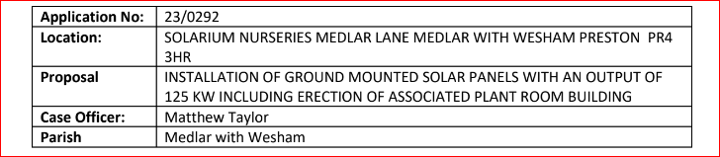

22/0616 – Employment building @ Mill Farm Revised Plans

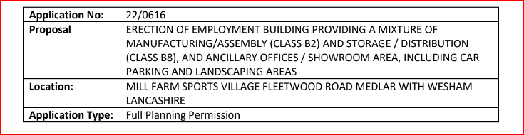

Applications 20/0135 (CPMS condition) & 21/0894 (North Stand) @ Mill Farm

Revised Car Park Management Proposal

23/0256 – Accentuation Pond @ Mill Farm

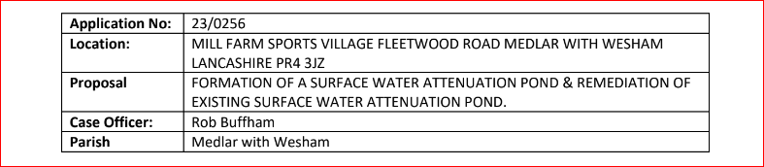

- Planning Consultation - E-mail 28/06/2023
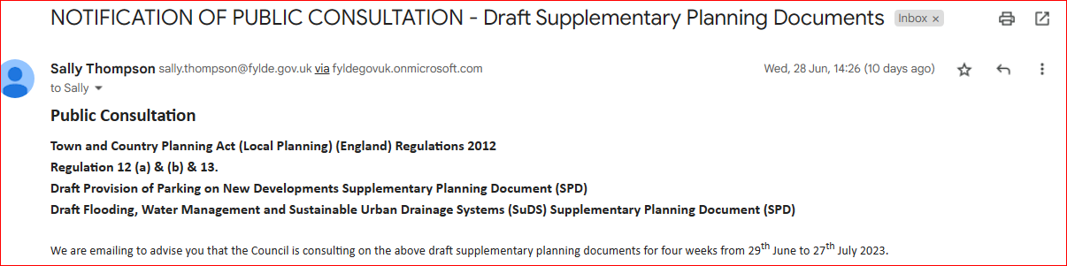

23/081 PLAYING FIELDS and OPEN SPACES -
- Open Spaces Contract - to discuss any issues raised by Councillors
- Coronation Living Heritage Fund ?
further planting to increase the number trees.

- Fleetwood Road Playing Fields - to discussed any issues raised

- Moles treatment quote

- Pavilion Repairs (recent inspection by KJFC - BS & WTC- DN)
1. There is a leak coming from the water supply main valve.
2. Toilets - KJFC want to replace with new toilets and also re-arrange slightly the access to that the “changing area” used for storage is lockable and the toilets accessible.
3. They would like permission to have a skip delivered on a specific day at a specific time to remove a lot of rubbish (accepting that they know it’s a magnet for local rubbish collection!)
4. We noted the guttering needs fixing or most likely, replacing
5. There is a distinct gap in the fence where they store their goal posts which is large enough for kids to get through and cause damage which they would like to close
6. There are brackets on the front of the pavilion that are almost falling off that we agree should be removed
7. They are considering a basic kitchen refurb
In general, they requested that WTC pay for the external (guttering, bracket removal and fence) and they pay for the rest. In view of previous experience in terms of them doing nothing, I suggested a single contractor with a single bill and we, if agreed, meet the cost of any bits we agree to. This would work particularly well as Barry thinks he can get some funding so the cost to WTC would effectively be half what it would be.

- Doorstep Green, Derby Road .
- Trees maintenance on Derby Road – NHS hospital estates area
- dog walking area ( shelter and broken bin)
- Street Cleaning in Wesham - nothing for Sept 2023 mtg
- Allotments
- Drainage - investigation update?
Flooding from allotments into Properties on adjacent estate - Douglas Ave
- Wesham Bowling Club
- winter work quotation
- Dog PSPO extension Alcohol PSPO extension – WTC response to FBC
23/082 HIGHWAYS AND RAILWAYS – to discussed any issues raised
SPID Purchase - WTC/Road Safety Trust ?

23/083 GOVERNANCE, FINANCE AND INSURANCE

Accounts payable and income received report –

WTC Monthly summary – July & August 2023

Application for additional account update

Mayoral donation

DN - Air Ambulance

SH - Food Banks

DN – NoticeBoards

SH - Food Banks

Freckleton Marsh Chq – benches & location

Accident and Incident Reporting – none

- 23/084 EVENTS - nothing for Sept 2023 mtg
- Community Club Day Field Event
– SH & Town Clerk to meet re expenses breakdown

23/085 HUMAN RESOURCES
- HR sub Committee – update?

23/086 WESHAM COMMUNITY CENTRE -
- Heating maintenance quotation
- Car parking issues – WCC/Church Road/Disabled space
23/087 OTHER
- Kirkham Swimming Baths closure
- War Memorial Clean
- Smoking issues @ Rehabilitation Centre, Mowbreck Lane
- Website
- Actions

DATE OF NEXT WTC monthly meetings: –
14th Sept 2023
17th Oct 2023

WTC Additional Meetings
Date | Meeting
11th Sept 2023 | Co-option WTC Councillor interviews
14th Sept 2023 | WTC Monthly meeting

Angela Hunter Date: 8th Sept 2023

